AMERICAN STYLE HEINNER

HSBS-HM442NFGBKE++
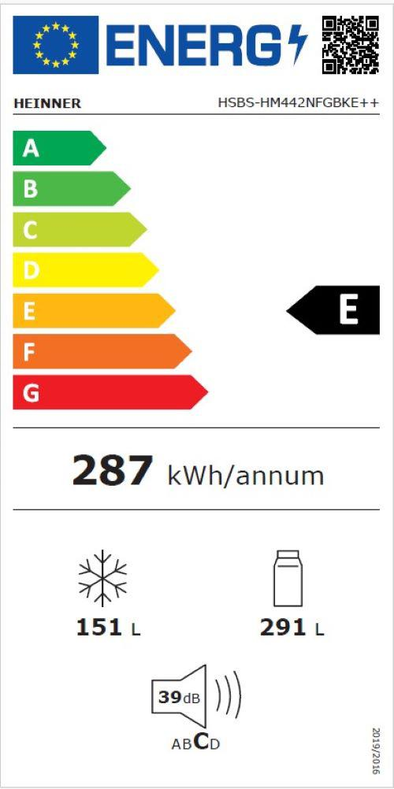
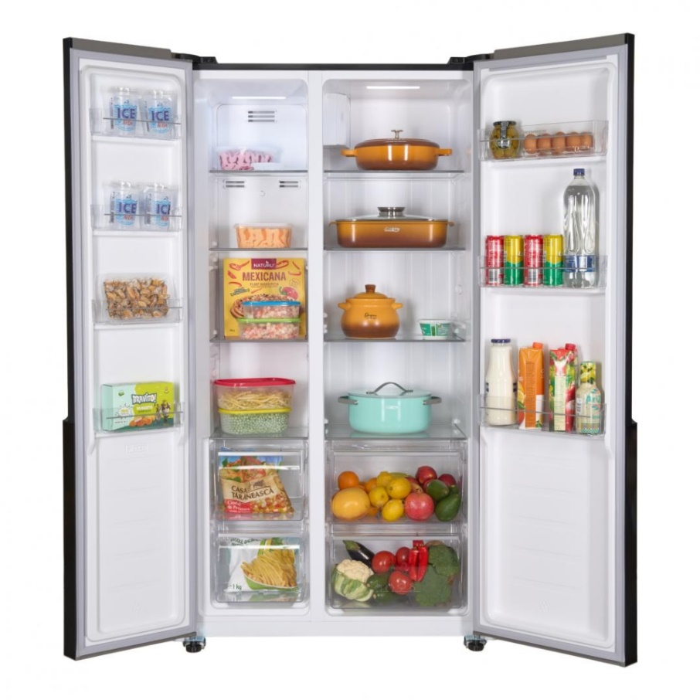



Description
- Full No frost,
- Inverter compressor,
- Energy efficiency class: E,
- LED display with touch control,
- Total capacity: 442L, Fridge capacity: 291L, Freezer capacity: 151L,
- LED light
- 3 fridge glass shelves, 2 compartment for fruits and vegetables, 3 freezer glass shelves, 2 freezer drawers,
- Dimensions (WxDxH): 90 x 59 x 177 cm
- , Color: black glass

Tel: 21250980 / 21233566
web: www.centrocasalinga.com

