

**Gorenje Built In Gas Hob**

**GKT6SYW-426141**

* **SmartControl**
* **SimpleOff program timer**
* **Wok burner** Wok triple burner
* **Ignition device**
* **Cast iron grid**
* Location of 1st heating element Front left
* Type of 1st heating element Triple burner
* Dimension of 1st heating element 103 mm
* Power of 1st heating element 3300 W
* Location of 2nd heating element Front right
* Type of 2nd heating element Spare burner
* Dimension of 2nd heating element 43 mm
* Power of 2nd heating element 1000 W
* Location of 3rd heating element Rear left
* Type of 3rd heating element Standard burner
* Dimension of 3rd heating element 67 mm
* Power of 3rd heating element 1750 W
* Location of 4th heating element Rear right
* Type of 4th heating element Standard burner
* Dimension of 4th heating element 67 mm
* Power of 4th heating element 1750 W
* Type of regulation Mechanical
* Type of pan support Cast iron
* Type of safety device for gas Electromagnetic valve
* Ignition system Yes
* Electronic timer Switch-off
* Voltage (V) **230 V**
* Frequency (Hz) **50 Hz**
* Required niche size for installation (mm) **560 X 490**
* Dimensions of the product (mm) **580 W X 510 D**
* Net weight (kg) **9,0 kg**
* Gross weight (kg) **9.0 kg**

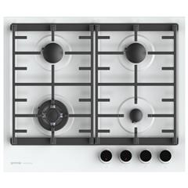

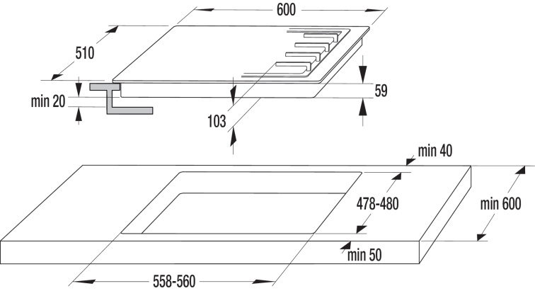

**Available in Black**

Glass Hob

Tel : 21250980 / 21233566 web:www.centrocasalinga.com